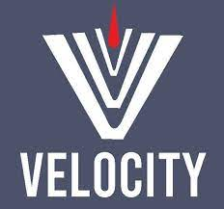**------------------------------------------------------------------**

**Manual Testing by Vaibhav Sir**

**---------------------------------------------------------------------**

**Contents Page No.**

1. Test Documentation hierarchy. 01
2. Software Testing Life Cycle. 04
3. Test Case Design
4. Test Case Review
5. Traceability Matrix
6. Defect Life Cycle
7. Reproducible, Duplicate, Leakage of Defect
8. Test Report
9. Pesticide Paradox
10. Testing Principles

# Test Documentation –

**Q. What is your organization Test documentation?**

* Test Document hierarchy.

Quality control – QC/

Testing Head -TH

Company Level document

**Test Plan**

**Test Methodology**

**Test Strategy**

**Test Policy**

Test Strategist – TS & PM

Project manager – PM

TRM

Team Lead – TL

**Test Scenario/ Case**

Team Lead – TL

Tester – Tester

Project Level document

**Test Procedure/Design**

**Test Script/ Execution (Test Proof)**

**Defect Report**

**Test Summary Report**

**Final Report/ Test closer Report**

**Test Policy**

* Test policy defines the **Objective** of the Project.
* Test Policy is decided by **Test Head**
* Test Policy is **the company level document.**

**Test Strategy.**

* Test Strategy defines as which approach is going to apply to fulfill the project objective.
* Test strategy is a Company level document.
* E.g. which language is going used like Java, Python, JavaScript etc, Which Tools used Eclipse, JIRA, TestComplete. Automation Testing Tool
* Test Strategy is defined by Test Strategist.

**Test Methodology (PM)**

* Test methodology defines which environment which we are going to us for fulfill the strategy.
* **Project Manager** decides the test methodology.
* Test Methodology documents are Project level documents.
* PM will prepare TRM Test Responsibility Matrix
* In the **TRM it defines the development stages are mapped with the testing factors.**
* While Preparing TRM generally considers
  + Project Requirements.
  + Project Scope.
  + Risk in Project.

|  |  |  |  |  |  |
| --- | --- | --- | --- | --- | --- |
| Development Stage  Testing Factor | Info Gathering / Analysis | Design | Coding | Testing | Maintenance |
| System and Functionality Testing. | No | No | YES | YES | YES |
| Security Testing | NO | No | No | YES | YES |
| Performance | NO | No | No | YES | YES |
| Usability Testing | NO | NO | YES | YES | YES |

**Test Plan**

* Test plan consist of **Resource Allocation, Job Allocation** ( 4 QA , 2 QA – Manual, 1QA – Manual/Automation – Lead : Automation)
* Test plan consist of the Estimation
* Test Plan documents are Project level document
* Test Plan document is prepared by **Team Lead.**

**Test Scenario/ Case or Test Case Design**

* QA will identify the testing scenarios.
* Based on the scenarios QA will design (Write) test cases.
* These documents are project level documents.

**Test Case Execution and Test Proof and Defect Logging.**

* In the test case execution; QA execute all the test cases designed as per the user story.
* While performing or While executing the test cases QA prepares the Test Proof (QA Captures the Screenshot or Videos if required)
* While executing the test cases if any of test cases fail or QA found any defect then QA will log a defect.

**Test Summary Report / Test Closure Report**

* Test Lead will create a Test Summary Report and Test Closure Report
* It consist of **No of Test Cases Designed, No Test Cases Executed, No Test Cases Pass, No Test Cases Fail, No Test Cases Skipped.**
* Test Summary Report and Test Closure reports are Project level document.

|  |  |  |  |  |  |  |
| --- | --- | --- | --- | --- | --- | --- |
| QA | **No of Test Cases Designed** | **No Test Cases Executed** | PASS | FAIL | SKIPPED | US Assigned |
| Sachin | 50 | 50 | 49 | 01 | 0 | 4 |
| Prajakta | 25 | 25 |  |  |  |  |
| Nitin | 20 | 20 |  |  |  |  |
| Seema | 05 | 05 |  |  |  |  |

-----------------------------------------------------------------------------------------------------------

**Software Testing Life Cycle (STLC)**

**BRS**

Testing

Development

**SRS/FRS/CRS**

**Design Test Initiation Stage**

**Coding Test Plane**

**STLC**

**Unit Testing Test Case Design**

**SDLC**

**Integration Testing Test Case Execution & Closer**

**(Install Build)**

**Level 0 Sanity/ Smoke Testing (**Check theStability of build)

**Level 1 BBT/ System & function testing (**Intern & External**)**

**(**If found **defect** sent to developer) (Inform throw **JIRA**)

**Level 2 Retesting / Regression Testing on Modified built.**

**Level 3 Final Regression Testing.**

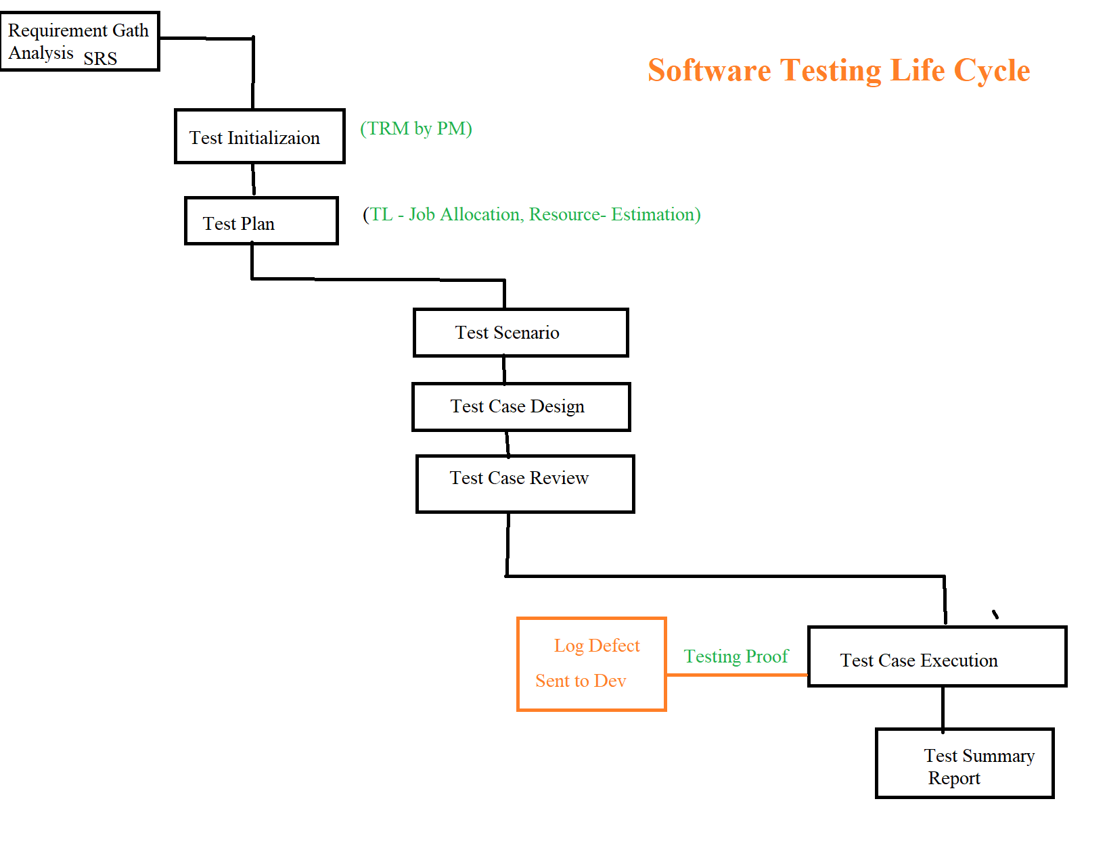

**Test Initialize. (PM - TRM)**

* In the Test Initialization Test Responsibility Matrix TRM document is prepared by PM.
* Once TRM document is finalizes it send to the Team (QA and Dev)
* In the TRM, Dev Stages are mapped with the testing factors.

**Test Plan.**

* The purpose of the Test plan is to Plan the Sprint from Starting Date to ending date of the Sprint.
* E.g. Sprint Start Date – 28/11/2022 and Sprint End Date – 12/12/2022.
* 10 Days. – 4 QA - (Work?? 16 US, Automation – 15 TC Automate) – Work Distribute.
* Test Plan is prepared by Team Lead (TL) QA.
* It consist of No of QA available, Environment, Work Allocation and Estimation.

Resource Allocation – JOB Allocation – Estimation

What to Test – When to Test – How to Test

Test Scenario

Test Case Design